PRACTICAL FILE

COURSE : SOFTWARE ENGINEERING METHODOLOGIES
SUBJECT CODE : SE-209n
B.TECH SEMESTER-V



^{DELHI TECHNOLOGICAL UNIVERSITY}
(FORMELY DELHI COLLEGE OF ENGINEERING)
^{BAWANA ROAD , DELHI – 110042}

^{SUBMITED BY : LOKESH GODARA}
^{ROLL NO . : 23/MC/082}
SUBMITED TO : Mr. AYUSH AWASTHI
INDEX
S.No. | Experiments | Date | Remarks
1. | Write a problem statement on the Online Course Registration system. | 22-Aug-2025
2. | Design a use case diagram on the Online Course Registration system. | 29-Aug-2025
3. | Write a brief description about use case diagram. | 12-Sept-2025
4. | Draw level 0, 1, and 2 DFD (Data Flow Diagram) on the Online Course Registration system. | 3-oct-2025
5. | Draw E-R diagram (Entity-Relationship diagram) of the Online Course Registration system. | 3-oct-2025
6. | Draw a class diagram for the Online Course Registration system. | 10-oct-2025
7. | Write/design SRS (Software Requirements Specification) for the Online Course Registration system. | 10-oct-2025
8. | Design test cases for the inventory management system using boundary value method. (Note: This task specifically mentions inventory management and was not changed.) | 17-oct-2025
9. | Write a program in C to implement COCOMO model. | 31-oct-2025
10. | Write a program in C to implement function point method. | 31-oct-2025

Experiment 1

AIM: Write a problem statement on the Online Course Registration system.

Introduction:
Online course registration systems have revolutionized the academic enrollment process by enabling students to register for courses remotely, eliminating the need for physical presence and reducing administrative burdens. Traditional registration methods required students to visit institutions, fill out paper forms, and wait for approvals, which was time-consuming and inefficient. With online course registration, students can browse available courses, check seat availability, register, and receive instant confirmation. This digital transformation enhances accessibility, reduces errors, and streamlines academic administration.

Hardware Requirements:
- Server: To host the registration system and store student and course data.
- Computers/Laptops: Used by students and administrators to access the system.
- Internet Connection: Required for remote access and real-time updates.
- Database Storage: To manage large volumes of student and course information.
- Security Devices: Firewalls and encryption to ensure data protection.

Software Requirements:
- Operating System: Windows, Linux, or macOS for hosting and accessing the system.
- Database Management System (DBMS): MySQL, PostgreSQL, or Oracle to store and manage data.
- Web Server: Apache or Nginx for hosting the web-based application.
- Front-End Framework: React, Angular, or Vue.js for a user-friendly interface.
- Back-End Framework: Django, Node.js, or Laravel to handle user authentication and data processing.
- Security Software: SSL encryption and authentication mechanisms to protect user data.

Functional Requirements:
- User Registration: Students and faculty members should be able to create accounts.
- Course Selection: Students should browse and select available courses.
- Real-Time Seat Availability: Display the number of available seats per course.
- Schedule Management: Ensure students do not enroll in conflicting courses.
- Payment Integration: Enable fee payments for premium courses if applicable.
- Automated Confirmation: Send instant notifications upon successful registration.
- Admin Dashboard: Allow administrators to add, modify, and remove courses.

Non-Functional Requirements:
- Scalability: The system should support a growing number of users.
- Security: Secure user credentials and personal data with encryption.
- Availability: The system should be accessible 24/7 with minimal downtime.
- Performance: Fast response times for queries and registration processes.
- Usability: Intuitive and user-friendly interface for easy navigation.

Problem Statements:
- Manual Registration Hassles: Traditional registration involves paperwork and manual approvals, leading to inefficiencies.
- Limited Registration Windows: Fixed working hours restrict students from registering at their convenience.
- Scheduling Conflicts: Overlapping classes create confusion for students and administrators.
- Data Inconsistencies: Manual errors can lead to incorrect course enrollments.
- Lack of Transparency: Students may not have real-time information on seat availability.
- Payment Challenges: Without online payment options, fee processing is delayed.
- Administrative Overload: Staff need to process each registration manually, leading to delays.

Conclusion:
The transition from manual to online course registration streamlines the enrollment process, enhances user experience, and improves operational efficiency. By implementing a digital solution, students can register seamlessly, institutions can manage enrollments effectively, and administrative workloads are significantly reduced. This advancement in academic administration underscores the growing need for technology-driven solutions in education.

Experiment 4

AIM: Draw level 0, 1, and 2 DFD (Data Flow Diagram) on the Online Course Registration system.
Introduction:
Data Flow Diagrams (DFDs) serve as potent visual tools in systems analysis and design, portraying the flow of data within a system. The process of developing DFD levels for a Course Registration system involves constructing a hierarchical representation of the system's functions and interactions.
Definition:
The development of DFD levels for a Course Registration system encompasses crafting a series of hierarchical diagrams showing the flow of data and processes within the system. The initial level furnishes a broad overview of major components and external entities, while subsequent levels dissect these components into finer details. These diagrams utilize standardized symbols for processes, data stores, data flows, and external entities, facilitating the analysis, design, and communication of the Course Registration system's structure and functionality. The multi-level approach facilitates a step-by-step exploration of the system's intricacies, augmenting clarity and comprehension for stakeholders involved.
Types of DFDs, Their Definitions, and Diagrams
A DFD of a Course Registration System consists of two levels: Level 0 DFD, Level 1 DFD, and Level 2 DFD.
Level 0 DFD
DFD Level 0, recognized as a Context Diagram, serves as a fundamental overview of a system or process. As the highest level of DFD, it offers a simple, top-level view of the system.
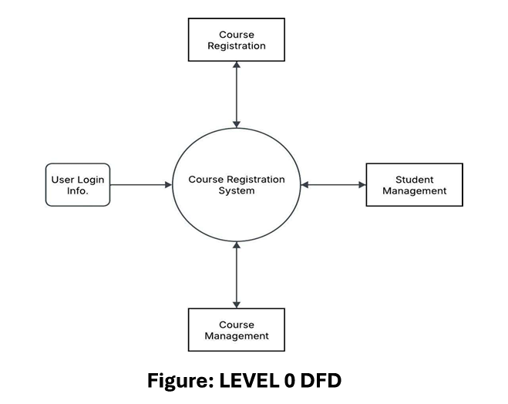
Level 1 DFD
A Level 1 Data Flow Diagram (DFD) provides a general overview, deconstructing a single process node from a context diagram into sub-processes. It can be conceptualized as an "exploded view" of the context diagram.
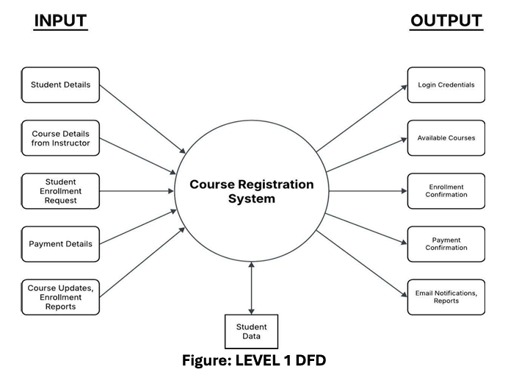
Level 2 DFD
A Level 2 Data Flow Diagram (DFD) supplies a more intricate view of specific processes identified in a Level 1 DFD. It dissects complex processes into smaller, detailed subprocesses, frequently encompassing data stores and flows between them. Level 2 DFDs yield a more granular comprehension of system functionality, proving valuable for system analysts and designers.
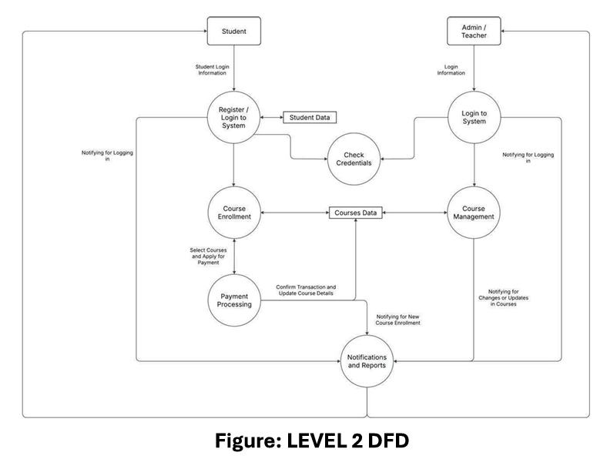
What Level 2 DFD Represents
Processes:
- User Registration/Login (2.1) → Handles student and admin login.
- Course Enrollment (2.2) → Allows students to browse and select courses.
- Course Management (2.3) → Allows admin/teachers to browse and update courses.
- Payment Processing (2.4) → If applicable, manages fee payments for courses.
- Notification System (2.5) → Sends confirmation emails or notifications.
Entities:
- Students → Users who register for courses.
- Admin/Registrar → Manages course availability and student enrollment.
Data Stores:
- Student Database → Stores student profiles and registration records.
- Course Database → Contains course details, availability, prerequisites.
- System Database → Stores student records, course details, and schedules.
Data Flows:
- Student Data → Check Credentials.
- Admin Data → Check Credentials.
- Update Course Details → Courses Data.
- Student Request → Courses Data (Verification).
- Confirmation Details → Student and Admin.
The Level 2 DFD furnishes a more detailed view of data flow between these processes and modules within the Course Registration system, offering an enhanced understanding of the system's internal workings.

Experiment 5

AIM: Draw E-R diagram (Entity-Relationship diagram) of the Online Course Registration system.

Introduction:
An Entity-Relationship (ER) Diagram is a graphical model that visualizes the entities and their relationships within a system. It is a critical component of the database design process, showing how data is organized and connected. ER diagrams help developers, designers, and stakeholders understand the system's architecture and data flow, which leads to a proper and efficient database design.

Components of an ER Diagram:
- Entities: Real-world objects or concepts represented as rectangles. Examples include Student, Course, Faculty, Department, and Admin.
- Attributes: Characteristics or properties of an entity, shown as ovals connected to their respective entities. For example: Student ID, Name, Age, Email for a Student.
- Relationships: Define how entities are associated with each other, represented by a diamond shape between entities.
- Cardinality: Specifies the number of instances of one entity related to another, indicated using notations like 1:1, 1:M (one-to-many), and M: N (many-to-many).

ER Diagram:

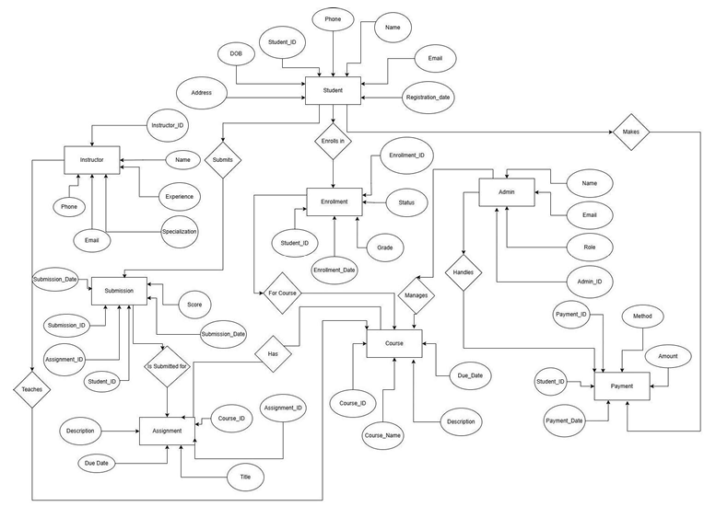

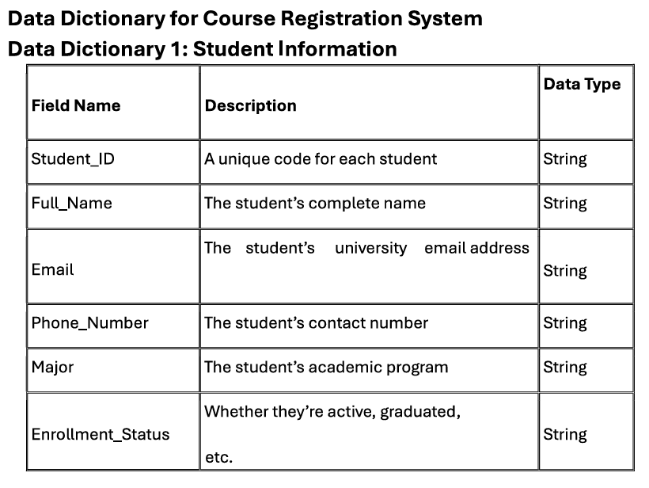

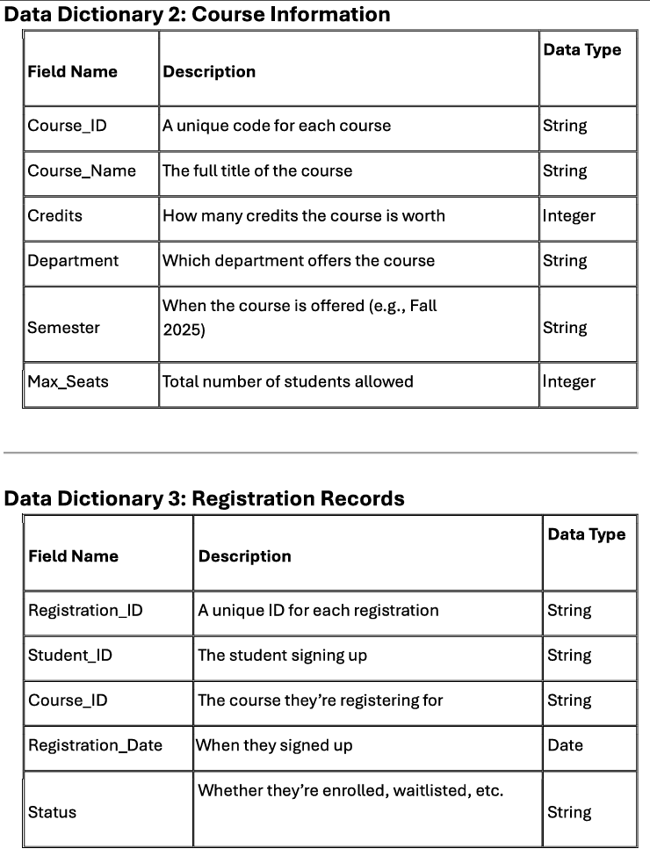
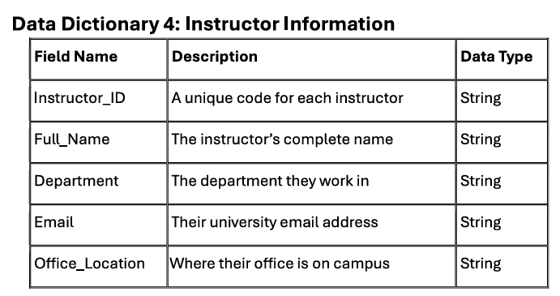
Conclusion:
The ER Diagram for an Online Course Reservation System provides a clear and structured visualization of the system's data relationships. It serves as a foundational blueprint for designing an efficient database, ensuring smooth data management, integrity, and security.

Experiment 7

AIM: Write/design SRS (Software Requirements Specification) for the Online Course Registration system.

1. Introduction
1.1 Purpose
The purpose of this SRS document is to define the functional and non-functional requirements for the Course Registration System. It serves as a reference for stakeholders, including developers, testers, project managers, and academic administrators, ensuring the project aligns with its objectives.
1.2 Scope
The Course Registration System is a web-based application designed to facilitate student enrollment in courses. The system allows students to browse, select, and register for courses, while administrators and faculty manage course offerings and class capacities. The aim is to streamline the registration process, improve efficiency, and ensure accurate record-keeping.
2. Overall Description
2.1 Product Perspective
The system integrates within the institution's academic management infrastructure, functioning as a standalone web application. It interacts with user roles such as students, faculty, and administrators.
2.2 Product Functions
- User Authentication: Secure login for students, faculty, and administrators.
- Course Catalog: Provides a list of available courses with details like prerequisites and schedules.
- Registration Process: Students can enroll in courses based on eligibility and availability.
- Prerequisite Verification: Ensures students meet requirements before registration.
- Seat Management: Tracks course capacities and waitlist management.
- Notifications: Sends email or system notifications for registration updates.
- Reports & Logs: Maintains records of course enrollments and student schedules.
- System Administration: Administrators can add/update courses, manage users, and generate reports.
2.3 User Classes and Characteristics
- Students: Users who browse courses, register, and manage their schedules.
- Faculty: Users who manage course content and track student enrollments.
- Administrators: Users who oversee course offerings, manage policies, and generate reports.
2.4 Operating Environment
The system will be a web application accessible via modern web browsers and hosted on a cloud-based or on-premise server. It will support Windows, Linux, and Mac OS environments.
3. Specific Requirements
3.1 External Interface Requirements
- User Interfaces: Shall provide a web-based GUI that is user-friendly and supports mobile and desktop access.
- Hardware Interfaces: Shall be accessible on any device with an internet connection.
- Software Interfaces: Integration with email services for notifications and a database connection for storing records.
3.2 Functional Requirements
- User Authentication: Users must log in; Role-based access control is required.
- Course Catalog: Display course descriptions, prerequisites, schedules, and real-time seat availability.
- Registration Process: Students can register for available courses; system shall prevent duplicate registrations.
- Prerequisite Verification: System shall validate prerequisite fulfillment before allowing registration.
- Seat Management: Enforce maximum seat limits; Waitlist functionality shall be implemented.
- Notifications: Automatic notifications for successful registration, waitlist updates, and course cancellations.
- Reports and Logs: Generate reports on enrollment trends and student schedules; Audit logs shall record user actions.
- System Administration: Administrators can add, update, or remove courses, and allow batch course updates for new semesters.
4. Non-functional Requirements
- Performance Requirements: Support concurrent users; Registration processing times shall not exceed 2 seconds.
- Security Requirements: All data transmissions shall be encrypted; Users shall be assigned appropriate role-based permissions.
- Usability Requirements: Intuitive interface with minimal training; Accessibility features shall be implemented.
- Reliability Requirements: Automated backups; System uptime shall be 99.9%.
- Scalability Requirements: Architecture shall support future expansion with minimal reconfiguration.
5. Other Requirements
- Legal and Regulatory Requirements: Comply with data privacy laws (e.g., GDPR) and institutional academic policies.
- Documentation Requirements: Provide User manuals and API documentation; include built-in help and tooltips

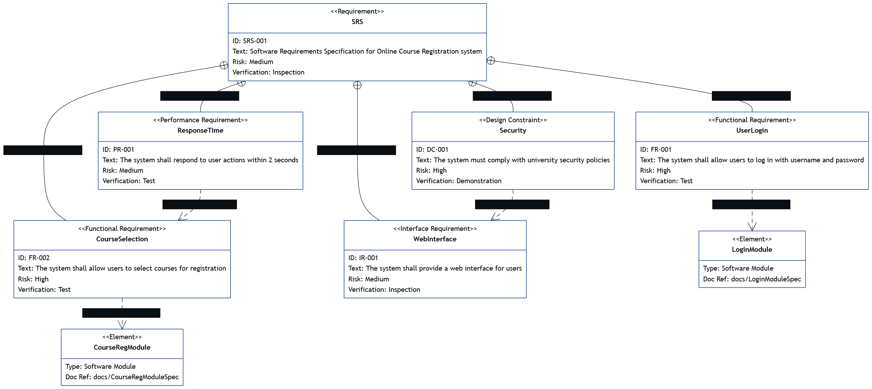

Experiment 2

AIM: Design a use case diagram on the Online Course Registration system.

Introduction:
The Use Case diagram for the Online Course Registration system outlines the various interactions between actors and the system itself. It illustrates the different functionalities and actions that users (actors) can perform within the system.
Diagram:
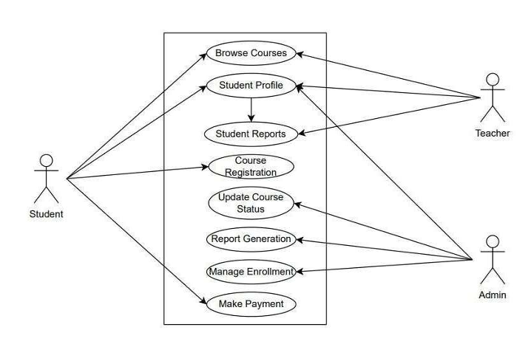
Actors:
- Student
  - Browse Courses
  - Apply for course registration
  - Make Payment
- Teacher
  - View Student Profile
  - Provide Student Reports
- Admin
  - Manage Courses
  - Manage Enrollments
  - Generate Reports for actions
Use Cases:
- Apply for Course Registration: Performed by Student to apply for registration in a course.
- Manage Courses Information and Status: Performed by Admin to update course information and status.
- Manage Enrollment: Performed by Admin to Add/Remove a student from a course.
- Generate Reports: Performed by Admin to generate reports and provide notifications to teachers and students.
- Provide Student Reports: Performed by teachers to give feedbacks and other reports to the student for their assignments, classes, etc..
Conclusion:
The Online Course Registration System use case offers a comprehensive solution to effectively manage course registration securely and efficiently. By integrating functionalities like payment processing, course management, student management, and user authentication, the system streamlines operations and enhances security.

Experiment 3

AIM: Write a brief description about use case diagram.
A Use Case Diagram is a behavioral diagram in UML (Unified Modeling Language) that shows the interaction between users (called actors) and the system. It defines the functional behavior of the system by identifying who does what. The use case diagram focuses on what the system should do, not how it is implemented.
The main purpose of a use case diagram is to understand the functional requirements of the system and to represent how different users interact with different functions. It helps developers and stakeholders visualize the overall functionality at a glance.
Main Components of a Use Case Diagram:
- Actors: The external users who interact with the system.
- Use Cases: The actions or tasks performed by the system.
- System Boundary: Represents the limit or scope of the system.
- Associations: Lines showing the communication between actors and use cases.
For the Online Course Registration System (OCRS):
- Actors: Student, Instructor, Administrator
- Main Use Cases:
  - Register for Course
  - Drop Course
  - View Course List
  - Manage Courses
  - Manage Students
  - View Enrolled Students
In this system, a Student can register or drop courses and view the course list. The Administrator manages courses and user accounts, while the Instructor can view the list of enrolled students. The entire interaction occurs within the boundary of the Online Course Registration System.
In simple terms, the use case diagram is like a map that shows who uses which feature of the system. It provides a clear understanding of the system’s scope and functionalities and is a foundation for other diagrams like DFDs, class diagrams, and SRS.
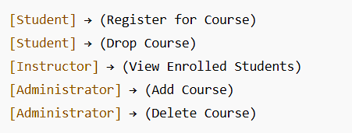
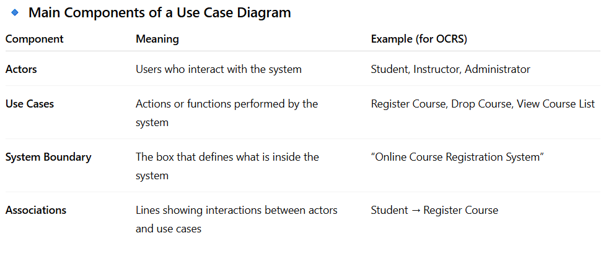

Conclusion:
The Use Case Diagram for the Online Course Registration System illustrates the interactions between users (students, instructors, and administrators) and the various functions they perform. It helps visualize the system’s requirements and improves communication between developers and stakeholders.

Experiment 8
AIM: Design test cases for the inventory management system using boundary value method.

Test Case Design using Boundary Value Method
Introduction
This document outlines test cases designed using the Boundary Value Method (BVM) for two distinct systems: an Inventory Management System and an Online Course Registration System. BVM is an effective technique for identifying defects by focusing on the boundaries of input partitions.
1. Inventory Management System
This section details test cases derived using the Boundary Value Method for a typical inventory management system.
Assumed System Inputs and Ranges for BVM:
Item ID: Assumed to be a numeric identifier ranging from 1000 to 9999.
Quantity in Stock: Assumed to range from 0 to 1000 units.
Reorder Level: Assumed to range from 0 to 200 units, and must be less than or equal to 'Quantity in Stock'.
Unit Price: Assumed to range from $0.01 to $500.00.
Boundary Value Test Cases: Inventory Management System
Field | Boundary Value Type | Test Value | Expected Outcome (Example)
Item ID | Minimum Value | 1000 | Valid Item ID, system processes correctly.
Item ID | Just Above Minimum | 1001 | Valid Item ID, system processes correctly.
Item ID | Maximum Value | 9999 | Valid Item ID, system processes correctly.
Item ID | Just Below Maximum | 9998 | Valid Item ID, system processes correctly.
Quantity in Stock | Minimum Value | 0 | Valid stock level, item might be marked as 'out of stock'.
Quantity in Stock | Just Above Minimum | 1 | Valid stock level.
Quantity in Stock | Maximum Value | 1000 | Valid stock level.
Quantity in Stock | Just Below Maximum | 999 | Valid stock level.
Reorder Level | Minimum Value | 0 | Valid reorder level.
Reorder Level | Just Above Minimum | 1 | Valid reorder level.
Reorder Level | Maximum Value | 200 | Valid reorder level.
Reorder Level | Just Below Maximum | 199 | Valid reorder level.
Reorder Level | Boundary Condition (RL <= Q) - RL=50, Q=49 | 50 (RL), 49 (Q) | System should trigger reorder notification or flag item.
Reorder Level | Boundary Condition (RL <= Q) - RL=50, Q=50 | 50 (RL), 50 (Q) | System should not trigger reorder notification (or based on specific policy).
Unit Price | Minimum Value | 0.01 | Valid price, system processes correctly.
Unit Price | Just Above Minimum | 0.02 | Valid price, system processes correctly.
Unit Price | Maximum Value | 500.00 | Valid price, system processes correctly.
Unit Price | Just Below Maximum | 499.99 | Valid price, system processes correctly.
2. Online Course Registration System
This section details test cases for an online course registration system, including a conceptual design representation.
Assumed System Inputs and Ranges for BVM:
Course Capacity: Assumed to range from 1 to 100 students.
Student ID: Assumed format (e.g., 202000001 to 202599999).
Age (for prerequisite/eligibility): Assumed range of 18 to 65 years.
Number of Credits (for course load): Assumed range of 1 to 18 credits.
Conceptual Design & Relevant Data for BVM:
The Online Course Registration System typically involves the following key entities and processes:
Component/Entity | Key Data Fields for BVM | Description
Course Management | Course ID, Course Capacity, Prerequisites (min age/credits) | Handles course creation, cataloging, and enrollment limits. BVM focuses on capacity limits and prerequisite values.
Student Management | Student ID, Academic Standing, Enrollment Status | Manages student profiles and eligibility. BVM is relevant for ID ranges and age-based eligibility.
Registration Process | Student ID, Course ID, Registration Date/Time, Payment Status | The core function where students enroll in courses. BVM tests limits of capacity, valid student IDs, and timing issues if applicable (e.g., registration open/close dates).
Prerequisites Checker | Student's Credits, Student's Age, Course's Min Age/Credits | Ensures students meet course requirements before enrollment. Critical for BVM on age and credit boundaries.
Boundary Value Test Cases: Online Course Registration System
Field | Boundary Value Type | Test Value | Expected Outcome (Example)
Course Capacity | Minimum Value | 1 | Course can be registered for, at least one student can enroll.
Course Capacity | Just Above Minimum | 2 | Course can be registered for.
Course Capacity | Maximum Value | 100 | Course can be registered for up to the maximum capacity.
Course Capacity | Just Below Maximum | 99 | Course can be registered for.
Student ID (Example Range: 202000001-202599999) | Minimum Value | 202000001 | Valid Student ID, registration should proceed.
Student ID (Example Range: 202000001-202599999) | Just Above Minimum | 202000002 | Valid Student ID, registration should proceed.
Student ID (Example Range: 202000001-202599999) | Maximum Value | 202599999 | Valid Student ID, registration should proceed.
Student ID (Example Range: 202000001-202599999) | Just Below Maximum | 202599998 | Valid Student ID, registration should proceed.
Age (for prerequisite) | Minimum Value | 18 | Student meets minimum age requirement for certain courses.
Age (for prerequisite) | Just Above Minimum | 19 | Student meets minimum age requirement.
Age (for prerequisite) | Maximum Value | 65 | Student meets maximum age requirement (if any).
Age (for prerequisite) | Just Below Maximum | 64 | Student meets maximum age requirement.
Number of Credits (for course load) | Minimum Value | 1 | Valid credit load for a student.
Number of Credits (for course load) | Just Above Minimum | 2 | Valid credit load.
Number of Credits (for course load) | Maximum Value | 18 | Student can register for maximum allowed credits.
Number of Credits (for course load) | Just Below Maximum | 17 | Valid credit load.
Conclusion
The Boundary Value Method provides a systematic approach to designing test cases that target potentially error-prone areas of software. By testing values at the edges of valid input ranges, we increase the likelihood of uncovering defects in both inventory and course registration systems.

Experiment 9

AIM: Write a program in C to implement COCOMO model.

CODE:
#include <stdio.h>
#include <math.h>
#include <stdlib.h>

typedef struct {
double a;
double b;
double c;
double d;
char mode_name[20];
} CocomoConstants;

int get_cocomo_mode() {
int choice;
printf("\n--- Basic COCOMO Model Estimation ---\n");
printf("Select the Development Mode:\n");
printf("1. Organic (Simple, small teams, experienced)\n");
printf("2. Semi-detached (Intermediate, mixed experience)\n");
printf("3. Embedded (Complex, rigid constraints, high reliability)\n");
printf("4. Exit\n");
printf("Enter your choice (1-4): ");
scanf("%d", &choice);
return choice;
}

void calculate_cocomo(double kloc, const CocomoConstants *constants) {
double effort_pm, time_months, staff_size;

effort_pm = constants->a * pow(kloc, constants->b);

time_months = constants->c * pow(effort_pm, constants->d);

staff_size = effort_pm / time_months;

printf("\n--- Estimation Results for %s Mode ---\n", constants->mode_name);
printf("Software Size (KLOC) : %.2f\n", kloc);
printf("Estimated Effort (Person-Months): %.2f PM\n", effort_pm);
printf("Estimated Development Time (Months): %.2f Months\n", time_months);
printf("Average Required Staff Size : %.2f Personnel\n", staff_size);
printf("--------------------------------------------------\n");
}

int main() {
CocomoConstants organic = { 2.4, 1.05, 2.5, 0.38, "Organic" };
CocomoConstants semidetached = { 3.0, 1.12, 2.5, 0.35, "Semi-detached" };
CocomoConstants embedded = { 3.6, 1.20, 2.5, 0.32, "Embedded" };

int choice;
double kloc;

while (1) {
choice = get_cocomo_mode();

if (choice == 4) {
printf("Exiting COCOMO Estimator. Goodbye!\n");
break;
}

if (choice >= 1 && choice <= 3) {
printf("\nEnter the size of the software in KLOC (Kilo Lines of Code, e.g., 50.5): ");
if (scanf("%lf", &kloc) != 1 || kloc <= 0) {
printf("Invalid input. Please enter a positive number for KLOC.\n");
while (getchar() != '\n');
continue;
}

switch (choice) {
case 1:
calculate_cocomo(kloc, &organic);
break;
case 2:
calculate_cocomo(kloc, &semidetached);
break;
case 3:
calculate_cocomo(kloc, &embedded);
break;
default:
printf("Invalid choice.\n");
}
} else {
printf("Invalid selection. Please choose a number from 1 to 4.\n");
}
}

return 0;
}

OUTPUT:

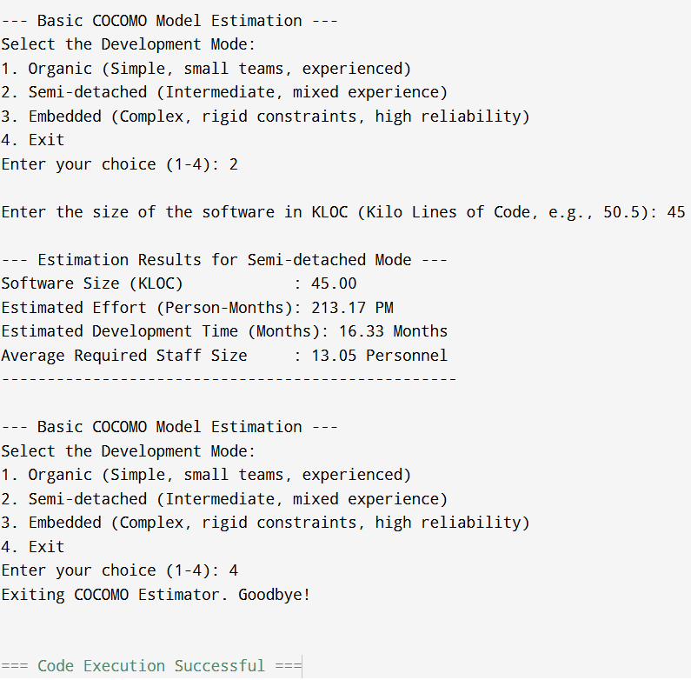

Experiment 10

AIM: Write a program in C to implement function point method.

CODE:

#include <stdio.h>
#include <stdlib.h>
#include <math.h>

const int WEIGHTS[5][3] = {
{3, 4, 6},
{4, 5, 7},
{3, 4, 6},
{7, 10, 15},
{5, 7, 10}
};

const char *COMPONENT_NAMES[] = {
"External Inputs (EI)",
"External Outputs (EO)",
"External Inquiries (EQ)",
"Internal Logical Files (ILF)",
"External Interface Files (EIF)"
};

const char *GSC_NAMES[14] = {
"Data Communications", "Distributed Data Processing", "Performance",
"Heavily Used Configuration", "Transaction Rate", "Online Data Entry",
"End-User Efficiency", "Online Update", "Complex Processing",
"Reusability", "Installation Ease", "Operational Ease",
"Multiple Sites", "Facilitate Change"
};

double calculate_ufp();
int get_rating(const char *gsc_name);
double calculate_vaf();
void calculate_and_display_results(double ufp, double vaf);

int main() {
printf("\n=======================================================\n");
printf(" Software Size Estimation: Function Point Method\n");
printf("=======================================================\n");

double unadjusted_fp = calculate_ufp();
printf("\n[STEP 1 COMPLETE] Unadjusted Function Points (UFP) = %.2f\n", unadjusted_fp);

double value_adjustment_factor = calculate_vaf();
printf("\n[STEP 2 COMPLETE] Value Adjustment Factor (VAF) = %.2f\n", value_adjustment_factor);

calculate_and_display_results(unadjusted_fp, value_adjustment_factor);

return 0;
}

double calculate_ufp() {
double total_ufp = 0.0;
int counts[3];

printf("\n--- Step 1: Calculate Unadjusted Function Points (UFP) ---\n");
printf("Please enter the count for each component type and complexity.\n");

for (int i = 0; i < 5; i++) {
printf("\nComponent: %s\n", COMPONENT_NAMES[i]);

for (int j = 0; j < 3; j++) {
const char *complexity_name = (j == 0) ? "Low" : (j == 1) ? "Average" : "High";
printf(" Enter count for %s complexity: ", complexity_name);

if (scanf("%d", &counts[j]) != 1 || counts[j] < 0) {
printf("Invalid input. Please enter a non-negative integer.\n");
while (getchar() != '\n');
j--;
continue;
}

total_ufp += (double)counts[j] * WEIGHTS[i][j];
}
}

return total_ufp;
}

int get_rating(const char *gsc_name) {
int rating;
while (1) {
printf(" %02d. %-30s (0-5): ", (int)(gsc_name - GSC_NAMES[0]) / sizeof(char *) + 1, gsc_name);
if (scanf("%d", &rating) == 1 && rating >= 0 && rating <= 5) {
return rating;
} else {
printf("Invalid input. Please enter a rating between 0 (No Influence) and 5 (Strong Influence).\n");
while (getchar() != '\n');
}
}
}

double calculate_vaf() {
int total_di = 0;

printf("\n--- Step 2: Rate General System Characteristics (GSCs) ---\n");
printf("Rate each characteristic on a scale of 0 to 5:\n");
printf(" (0: No Influence, 1: Incidental, 2: Moderate, 3: Average, 4: Significant, 5: Strong)\n");

for (int i = 0; i < 14; i++) {
total_di += get_rating(GSC_NAMES[i]);
}

printf("\nTotal Degree of Influence (DI) = %d\n", total_di);

double vaf = 0.65 + ((double)total_di / 100.0);

return vaf;
}

void calculate_and_display_results(double ufp, double vaf) {
double adjusted_fp = ufp * vaf;

const double PH_PER_FP = 10.0;
double effort_hours = adjusted_fp * PH_PER_FP;
double effort_months = effort_hours / (8.0 * 22.0);

printf("\n=======================================================\n");
printf(" FINAL ESTIMATION RESULTS\n");
printf("=======================================================\n");
printf("Unadjusted Function Points (UFP): %.2f FP\n", ufp);
printf("Value Adjustment Factor (VAF): %.3f\n", vaf);
printf("-------------------------------------------------------\n");
printf("ADJUSTED FUNCTION POINTS (AFP): %.2f FP\n", adjusted_fp);
printf("-------------------------------------------------------\n");
printf("Estimated Total Effort:\n");
printf(" @ %.1f Person-Hours/FP: %.0f Person-Hours\n", PH_PER_FP, effort_hours);
printf(" Estimated Project Duration: %.2f Person-Months\n", effort_months);
printf("=======================================================\n");
}

OUTPUT:

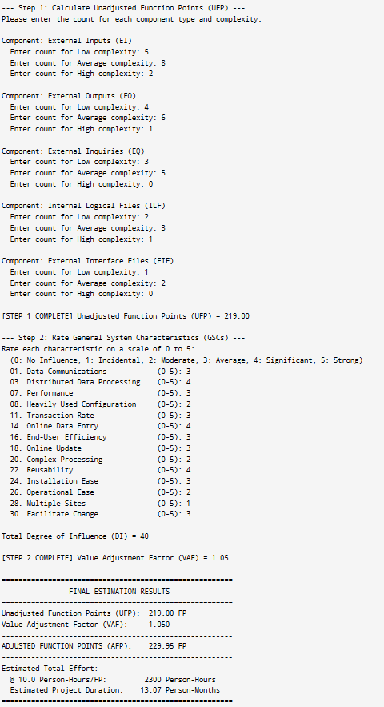
Experiment 6
AIM: Draw a class diagram for the Online Course Registration system

The class diagram shown above represents the object-oriented design of the Online Course Registration System (OCRS). It identifies the main classes, their attributes, methods, and the relationships between them.
The system contains the following primary classes: Student, Instructor, Department, Course, and Enrollment.
- Student Class:
Represents students who use the system to register for and drop courses. It includes attributes such as studentId, name, and email, and methods like registerCourse(), dropCourse(), and viewSchedule().
- Instructor Class:
Represents the faculty members who teach courses. It includes attributes like instructorId, name, and department, and operations such as assignCourse() and gradeStudent() to manage courses and student performance.
- Department Class:
Represents the academic departments that offer various courses. It has attributes such as departmentId and departmentName, and methods addCourse() and removeCourse() for course management.
- Course Class:
Represents the courses available for registration. It includes attributes like courseId, courseName, and creditHours, with methods addStudent(), removeStudent(), and listEnrolledStudents().
- Enrollment Class:
Acts as an association between Student and Course, representing the registration details. It includes enrollmentId, enrollmentDate, and status as attributes, and a method updateStatus() for maintaining the current enrollment status.
Relationships:
- A Student registers for one or more Courses through the Enrollment class.
- Each Course can have multiple Students, but is taught by one Instructor.
- Each Department offers one or more Courses.
- Enrollment forms a many-to-many link between Student and Course, maintaining registration details.

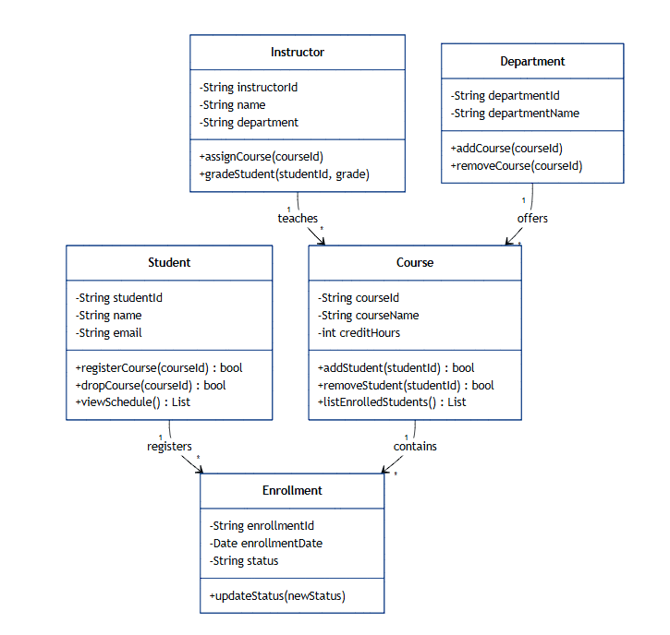

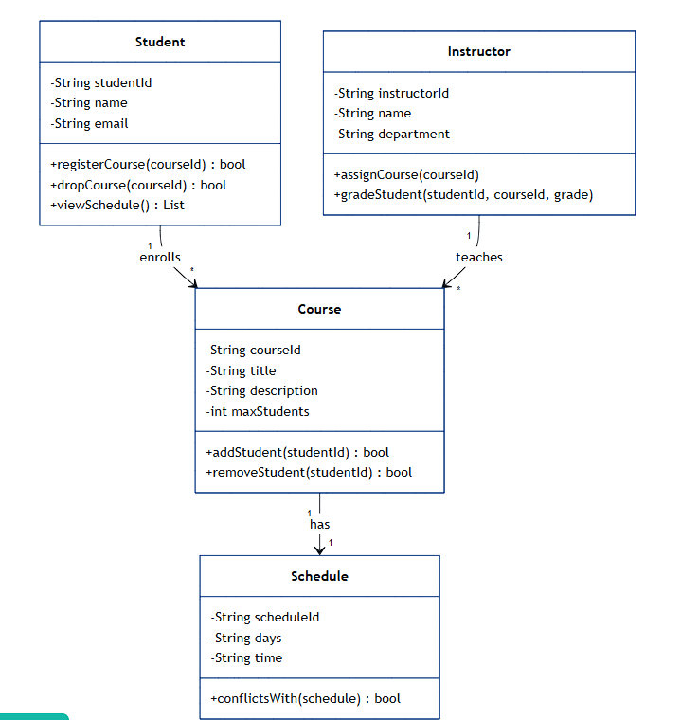
Relationships:
- A Student registers for many Courses (many-to-many) through Enrollment.
- Each Course is taught by one Instructor.
- A Department offers multiple Courses.
- Each Enrollment record links one student and one course.

Conclusion:
The Class Diagram for the Online Course Registration System clearly depicts how students, instructors, departments, courses, and enrollments are related. It helps visualize the system structure and serves as a blueprint for database and code implementation

